Project Development Phase
Performance Test

Date | 30 September 2026
Team ID | MKU201Team76ab4df35a238dc999eb5e6de
Project Name | Streamlining IT Procurement: Automating Standard Laptop Orders with Flow Designer
Maximum Marks

Model Performance Testing:
Project team shall fill the following information in model performance testing template.
S.No. | Parameter | Screenshot / Values
 | Data Rendered | Request REQ0010002 → Requested Item RITM0010002 (Standard Laptop) → Catalog Task SCTASK0010002 are rendered from the ServiceNow Service Catalog after the laptop order is placed.  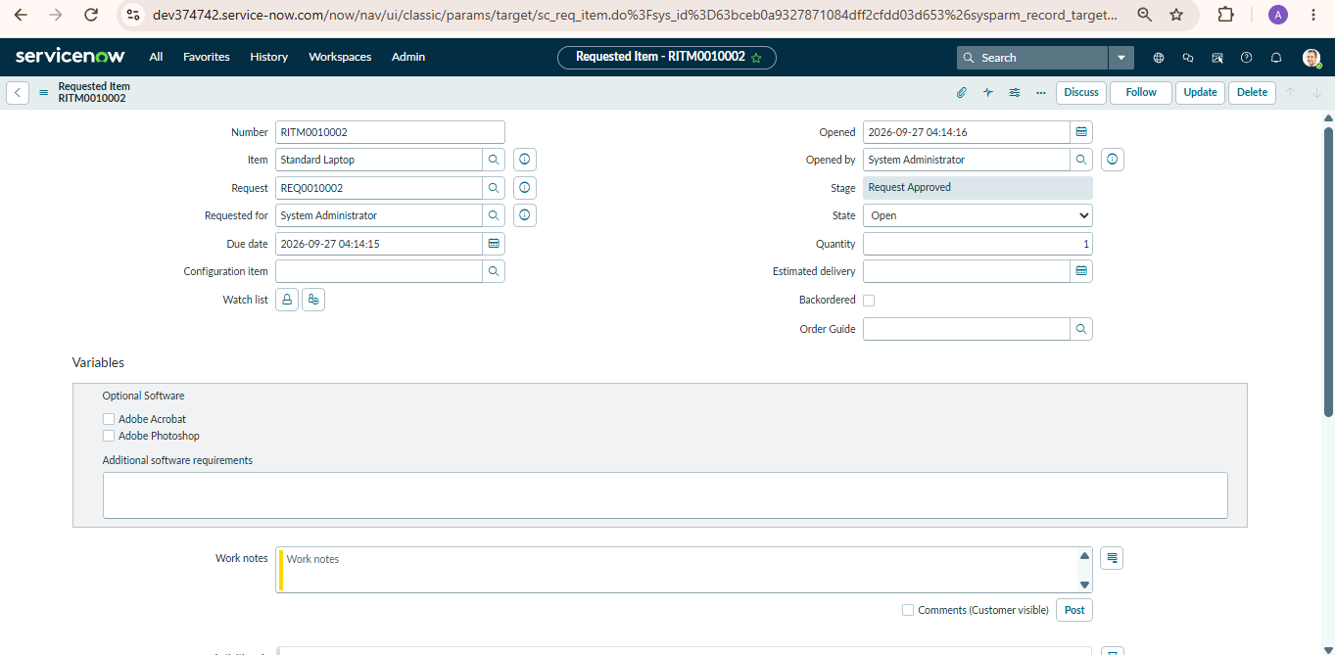
 | Data Preprocessing | No data cleaning required – order data comes directly from the catalog form. The flow trigger (Service Catalog) maps the Requested Item Record to the Request Item field of the Create Catalog Task action; Short Description and Description are pre-set; Run As: System User.  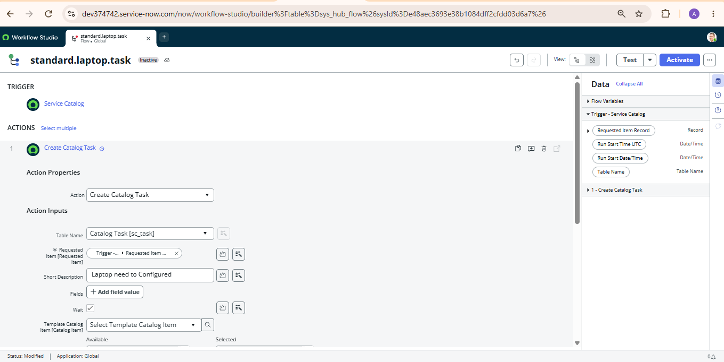
3. | Utilization of Filters | Standard Laptop item filtered in the Hardware category of the Service Catalog; Process Engine filter set to Flow; Assignment Group = Hardware; Approval = Approved.  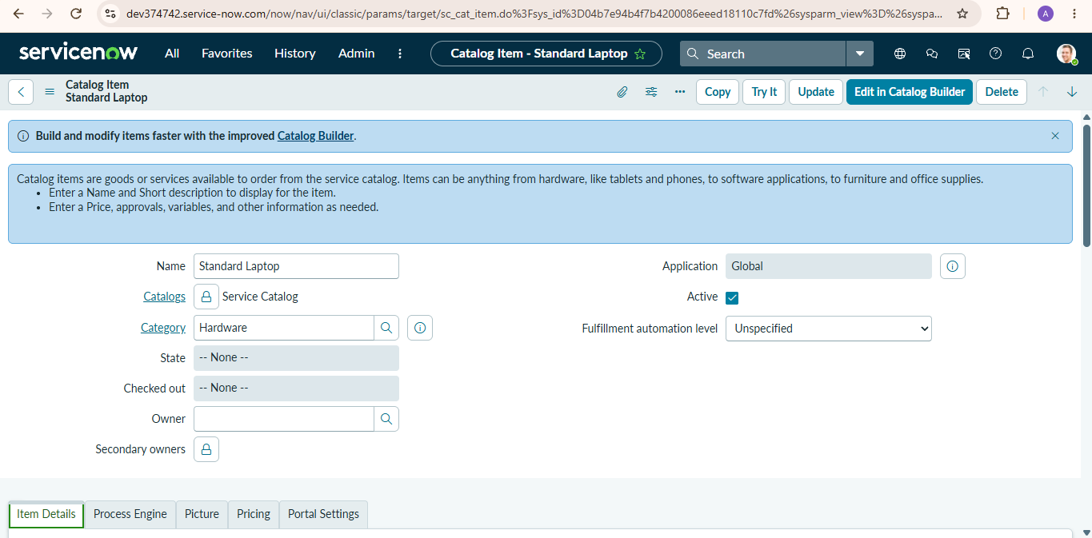
4. | Calculation fields Used | Not applicable – no calculated fields are used. Field mappings used in the flow: Requested Item ← Trigger › Requested Item Record; Short Description / Description = laptop configuration message; Assignment Group = Hardware; Approval = Approved.
5. | Dashboard design | No of Visualizations / Graphs - 0  Flow Designer view of the “Standard Laptop Task” flow (Service Catalog trigger and Create Catalog Task action) before activation.  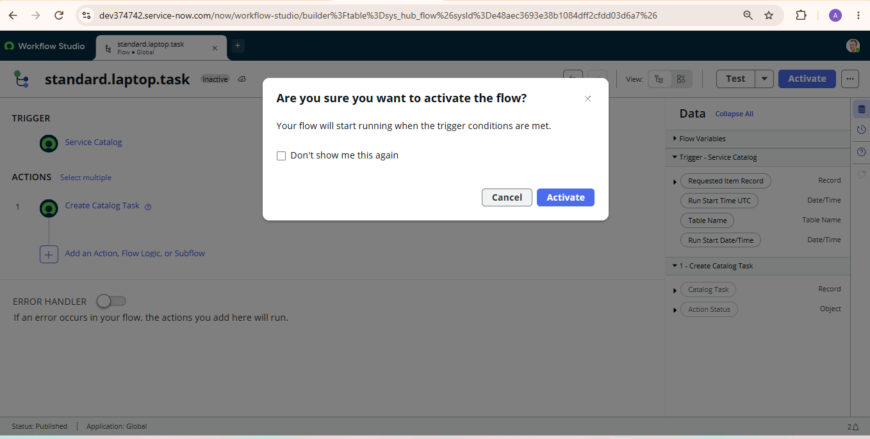
6 | Story Design | No of Visualizations / Graphs - 0  Process story in 3 milestones: Milestone 1 – Flow creation; Milestone 2 – Flow assignment to the Standard Laptop catalog item; Milestone 3 – Service Catalog order, approval and Catalog Task verification (5 screenshots).  